Dyslexia Policy
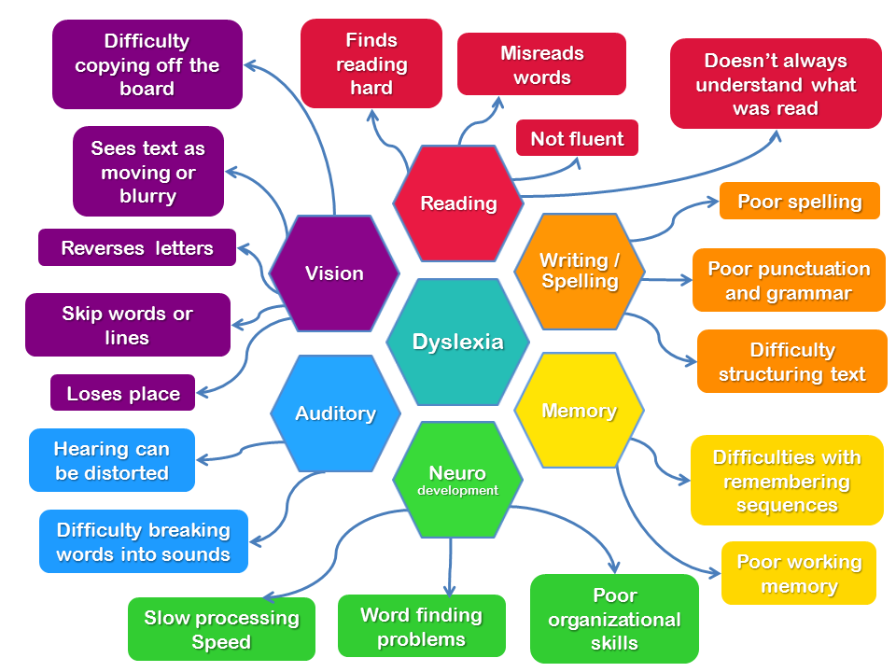

Prospect Vale Primary School
September 2022

Pupils with Specific Learning Difficulties (Dyslexia)
At Prospect Vale Primary School, we recognise that some pupils, despite often having average or above average intellectual ability and good oral skills, have unusual difficulty learning to read or to spell and write fluently. These pupils may be described as having specific learning difficulties or Dyslexia.
Dyslexia is best described as a continuum of difficulties in learning to read, spell or write, which persist despite appropriate learning opportunities. These difficulties are not typical of performance in most other cognitive and academic areas.
There may be associated difficulties in such areas as:
- phonological processing;
- short-term memory;
- sequencing;
- number skills;
- motor function;
- organisational ability.
We recognise that these pupils have special educational needs and that these needs have to be met to the best of our ability and resources; we recognise that these pupils have skills and talents which need to be nurtured and developed and that they have the same right of access to the curriculum and to all the activities of the school as all other pupils.
We will therefore make the following arrangements to try to ensure that their needs are met.
- All pupils in school will be taught in a Dyslexic friendly environment. This is reflected in classroom organisation, resources and teaching strategies.

- We observe pupils carefully to try to ensure that any child who is experiencing difficulties with aspects of literacy are identified as early in their school career as possible. These difficulties will be shared with parents/carers in a sensitive manner.

- We will assess and make provision for the child's difficulties within the framework of the Stages of the Code of Practice for the Identification and Assessment of Special Educational Needs. We will prepare appropriate support plans, setting out the provision we propose to make for the child and the objectives for that provision and the time scale. This provision will be discussed in partnership with the learner's parents, who will be kept informed of progress.

- If, despite our best endeavours to ameliorate the pupil's difficulties, it is felt that there is still a noticeable mismatch between the learner's oral skills (talking and listening) and their attainment in literacy skills and that they may need more specialist help than we are able to provide from within our resources, we may, following consultation with parents, seek further advice from Stockport’s Inclusion Services.

- A revised plan will set out the provision that we can make within our own resources, and the strategies which class teachers can adopt to help the learner access the curriculum. All teachers who teach the pupil will be made aware of their difficulties, will be made aware of the agreed plan and the agreed strategies to help give the pupil access to the curriculum.

- These strategies may, depending on the needs of the child, include the use of word banks, personal (illustrated) dictionaries, the use of spellcheckers and other spelling aids. We may, within the limits of our resources, allow the pupil to produce work using a word processor so that they should be able to edit it more easily. This will be considered, especially, in cases where the pupil has major difficulty with the technical aspects of handwriting or with speed of handwriting.

- All staff will try to be as sensitive as possible to sources of anxiety and feeling embarrassment, e.g. being asked to read aloud in class, being asked to copy large amounts of written material from the board.

- Teachers will take account of the child's difficulties when marking work by, for example, concentrating on content rather than absolute spelling or grammatical accuracy. They will also be aware of the need to find alternative ways of assessing progress rather than always through written tests.

- Teachers will take account of the pupil's difficulties when setting homework tasks. They will set homework which children will be able complete within a reasonable period of time. Teachers will also try to ensure that tasks set by different teachers (for example, class teacher and LSS teacher) are coordinated and do not impose an unfair burden on the pupil.

- We are aware that pupils with Specific Learning Difficulties (Dyslexia) have experienced perceived "failure" and that often their motivation for work involving literacy is low. We are conscious of the need to try to make these tasks as stimulating as possible and of the need to find ways of raising the pupil's motivation generally. This is particularly important since the nature of their difficulties means that there will need to be a good deal of repetition of basic work to ensure that reading vocabulary, spellings etc. are learned and retained.

- We will try to suggest ways in which parents can help us help their child. We believe that parents can contribute a great deal to an educational programme and that partnership with school is vital. Depending on the age and stage of the pupil, they may contribute by, for example, making and illustrating personal dictionaries and word banks; reading to their child on a regular basis; participating in paired reading schemes; hearing their child read every day; helping their child with study and revision.

Specific to End of Key Stage
- We will aim to make appropriate arrangements for pupils to undertake tests or examinations so that their knowledge, skills and understanding can be fairly assessed. This may involve giving the pupil additional time; allowing the questions to be read to him/her; allowing the pupil to use ICT equipment etc. We will apply for these special arrangements for pupils sitting Year 6 SATS, if it is established that the pupil meets the criteria for special arrangements.

Appendix A
GENERAL INDICATORS AND STRATEGIES
A pupil may display any of the following characteristics. The presence of a number of these characteristics may indicate that the child is developing Dyslexic learning difficulties. When considering these characteristics, it is important to remain mindful of the following:
a. No child will have all these characteristics.
b. Some characteristics are more common than others.
c. The number of symptoms seen in a particular child does not give an indication as to whether the dyslexia is mild or severe. It is important to consider if the behaviours are chronic and appear in clusters.
General Indicators
- Appears academically capable and able but can’t get thoughts down on paper.
- Reading achievement is below expectation.
- Can be clumsy.
- May become withdrawn and isolated.
- Memory problems:
- Has difficulty following instructions.
- Has difficulty remembering anything in a sequential order, ego tables, days of the week, the alphabet, multiplication.
- Has difficulty processing information.
- Poor time concepts, planning and organisational skills.
- An apparent lack of concentration.
- Excessive tiredness due to the amount of concentration and effort
required.
- Remembers best when shown what to do rather than when told what
to do.
- Will have a preferred learning style such as: -
Reading the work - this is the visual channel
So, you could encourage them to read aloud onto tape.
Writing it - this is the kinaesthetic channel
So, you could encourage them to write down the main points - helps commit them to memory.
Saying it - this is the auditory channel
Auditory learners like to hear information. Reading notes aloud helps to reinforce memory, check it again, this is using the thinking channel.
Reducing it - this requires thinking skills
So, encourage them to highlight the key words and note the associated ideas, try mind mapping, use coloured pens to list the key facts and number them.
- May have narrow, restricted written work in contrast to rich expressive
language.
- Performs unevenly day to day.
- May have sensitivity to glare.
- Family history is significant as dyslexia is often inherited. But
remember that parents may not be aware of their own dyslexia.

For a teacher in the classroom, the indicators listed above should raise the
possibility that the pupil has dyslexia.
Where there is a strong likelihood that a pupil may have dyslexia, even if a
formal “diagnosis” has not been made, the pupil’s teaching programme
should be drawn up, based on the suggestions and guidelines for good
practice.

Some general strategies
- Foster pupil positive self-esteem.
- Make expectations high for intellectual stimulation but reasonable for written responses.
- Be prepared to explain things many times and in a variety of ways.
- When giving instructions be slow, quiet and deliberate in your instruction, allowing time for the meaning of the words to ‘sink in’.
- Practice and over learning are vital for success.
- Where possible use multi-sensory methods of teaching; these integrate the visual, aural, oral and kinaesthetic senses to consolidate the learning experience.
- Be aware of different learning styles and be flexible in your teaching style.
- Use coloured paper instead of white.
- Modify teaching materials, control readability, print and presentation.
- Modify homework format and expectations.
Other possible indicators and strategies have been recorded for different age
groups and phases in the following sections.

INDICATORS IN THE EARLY YEARS (3-5 YRS)
Talking and Listening
- Is later than most children in learning to speak.
- Has difficulty pronouncing some, especially multi-syllabic, words.
- Has difficulty separating spoken words into sounds and blending (i.e. has difficulty with phonological awareness).
- Experiences auditory discrimination problems.
- Is prone to spoonerisms (for example, chish and fips for fish and chips).

Early Literacy Skills
- Is slow to add new words to own vocabulary.
- Exhibits delays in acquiring emergent literacy skills (e.g. understanding that written language progresses from left to right, discriminating between letters, words and sentences).

Memory
- Is unable to follow multi-step directions or routines.
- Experiences problems learning the alphabet.
- Has trouble learning numbers, days of the week, colours and shapes.
- Has trouble learning to write and spell his/her own name.

Motor Control
- Is developing fine motor skills more slowly than other children.
- May experience difficulty learning to use a knife and fork.
- May experience difficulty learning to dress, for example, what goes on first?
- Has difficulty in copying shapes with pencil or in colouring within lines.
- May have difficulty in doing simple jigsaws.
- Experiences difficulties with poor co-ordination, difficulties with buttons, laces, etc.
Behaviour
- Has poor concentration, is easily distracted, doesn’t settle to tasks.
A strong focus on prevention of learning difficulties between ages 3 and 5 may result in the identification of some ‘false positives’ – i.e. children who may be identified as being ‘at risk’ of developing learning difficulties arising from dyslexia and who may not develop such difficulties over time. Nevertheless, it is possible try to minimise the effects of learning difficulties by providing appropriate interventions at this stage. The main approach should be ‘when in doubt, act’.

STRATEGIES FOR THE EARLY YEARS (3-5YRS)
Talking and Listening
- Develop the awareness of sounds (phonological awareness), for example, play ‘I Spy’ and ‘odd-man-out’ activities.
- Work on alliteration, for example, ask the child to say which word is the odd one out, for example, sat/sun/pig/sad.
- Play musical instruments and get children to identify the instruments.
- Play ‘Simple Simon Says’ and other listening games.
- Use activities aimed at developing an awareness of sounds, for example, things to bang, blow or shake.

Early Literacy Skills
- Develop awareness of words and letters by playing games such as lotto/snap.
- Use taped stories - children follow the story in a book as they listen to the story from the tape.
- Use big books, which are visually attractive and have large print.
- Provide a range of printed material to help develop the notion that, “I am a reader”.

Memory
- Ensure you have the child’s full attention before speaking, for example, call the child by their name at the beginning of a sentence.
- Simplify instructions – pause between each part of an instruction, for example, ‘Before going out to play (pause) tidy up the jigsaws (pause) and go to the toilet’.
- Use non-verbal gestures, for example, pointing, facial cues to support verbal instructions.
- Make important words which convey understanding stand out, for example, for example, TIDY up the JIGSAWS.
- Link seasons and events, sequence days and months of year through visual cues and pictures.
Motor Control
- Colour code shoes on the sole or inside with a bright symbol to help distinguish left from right.
- Mark the toes of socks with bright cotton to prevent the child from fumbling while attempting to put his toe into the heel of the sock.
- Make use of commercially available aids or cardboard cut-outs to help the child learn to tie shoe laces.
- When teaching a child to button a coat or a cardigan, teach him to always begin at the bottom where he can easily see what he is doing.
- Use Velcro fastening shoes and trainers whenever possible.

Behaviour
- Involve the children in short tasks.
- Provide immediate praise.
- Use multi-sensory activities, for example, hands on activities and visually stimulating materials.
- Get the pupil to repeat an instruction to ensure complete understanding of task has occurred before allowing the child to begin activity.
- Use self-esteem enhancement exercises, for example, praising positive compliant behaviour, tactfully ignoring inappropriate behaviour.

- PRIMARY SCHOOL INDICATORS (5-11YRS)
- Talking and Listening
- Has difficulty learning the connection between letters and sounds.
- Has difficulty separating words into sounds and blending sounds to form words.
- Has difficulty repeating multi-syllabic words (e.g. emeny for enemy, pasghetti for spaghetti).
- Has word retrieval difficulties, unable to ‘find the word’, to pull it out of long-term memory.

Reading
- Has difficulty decoding single words (reading single words in isolation).
- Has poor word attack skills, especially for new words.
- Confuses small or ‘easy’ words: at/to; said/and.
- May make constant reading errors such as:
- Letter reversals (e.g. b/d as in dog for bog).
- Letter inversions (e.g. m/w).
- Letter transpositions (e.g. felt and left).
- Word reversals (e.g. tip for pit).
- Word substitutions (e.g. house for home).
- Reads slowly with little expression or fluency.
- Is slow at discerning and learning prefixes, suffixes, root words and other morphemes as part of reading and spelling strategies.
- Reading comprehension is better than single-word reading.
- Listening comprehension is better than reading comprehension.

Spelling
- Spelling is inappropriate for age and general ability (e.g. spelling the same word differently on the same page, use of bizarre spelling patterns, frequent letter omissions, additions and transpositions).
- Poor spelling contributes to poor written expression.
- Confusion of similar letters, e.g. b/d, p/q.
- Frequently transposes letters within words.
- Uses phonetic ‘alternative’ spellings (ate for eight).

Writing
- Has difficulty in copying accurately, especially from the blackboard.
- Poor handwriting – inconsistent spacing, poor formation of letters, untidiness of presentation.
- An inappropriate or inefficient pencil grip often with a high degree of tension.
- Interspersing of upper and lower case letters.

Memory
- An apparent lack of concentration or attention.
- Forgetfulness/ absentmindedness.
- Difficulty remembering oral directions or instructions (particularly a sequence of instructions).
- Remembers better when shown what to do rather than when told what to do.
- Problems with rote memory, e.g. tables or learning poetry.
- Difficulty remembering anything in a sequential order (days of the week, alphabet).

Behaviour
- Lacks self-confidence, particularly around reading and writing tasks.
- Uses avoidance tactics when asked to read orally or write.
- Poor motivation.
- Poor self-esteem.

PRIMARY SCHOOL STRATEGIES (5-11YRS)
Talking and Listening
- Provide phonic, structured, cumulative, multi-sensory tuition.
- Use practical activities/games that make phonemes more concrete.
- Provide training in listening skills.
- Encourage the child to seek clarification.

Reading
- Use visual, aural, oral and kinaesthetic senses. LOOK, SAY/HEAR,
- TRACE, COVER, WRITE, CHECK.
- Build on what has been securely taught leaving nothing to chance.
- Teach for automaticity – shared reading and repeated reading are useful techniques for developing fluency.
- Provide daily opportunities to read and write for real purposes.
- Select material to match both current ability and interest level.
- Use personalised high interest materials to aid motivation.
- Develop a paired reading programme with parents or peers to maximise exposure to language, promote fluency and expression and boost confidence.
- Never ask the pupil to read aloud in class. Reserve this for a quiet time away from the rest of the class.
- Emphasise comprehension and develop it by reading each word or sentence twice, rewriting text using simplified language, and using procedures such as cloze.
- Use ICT aids such as text-reading software.

Spelling
- Choose a structured multi-sensory spelling programme.
- Support independent writing with word walls.
- Encourage the child to use spelling resources to check the ‘I’m not sure’ words, e.g. personalised dictionary, spellchecker, ask a spelling buddy etc.
- Accept oral responses.

Writing
- Introduce joined writing at an appropriate stage, usually in Key Stage 1.
- Experiment with pencil grips and different types and sizes of writing implements.
- Make sure that words on the board are printed clearly.
- Write alternative lines in different colours.
- Allow plenty of time for copying from the board.
- Leave notes on the board as long as possible.
- Notes or handouts are much more useful to the pupil with dyslexia.
- Use scaffolding such as writing frames and plans.
- Reduce writing demands by the use of mind maps, flow diagrams etc.
- Use voice recording to a Dictaphone.
- Use a scribe.
- Mark written work on content, focus on what is correct rather than draw attention to all errors.

Memory
- Ensure the pupil has understood and remembered instructions.
- Ask pupil to repeat back any instructions given.
- Back up oral instructions with visual cues.
- Present information in graphical as well as verbal form, e.g. tables, flow charts, graphs, mind maps, spider diagrams.
- Use rhythm and music to facilitate retention of tables etc.
- Explore the use of mnemonics, e.g. Father and Mother I Love You
= family.

Behaviour
- Praise whenever possible.
- Acknowledge the pupil’s strengths, focus on achievement, encourage outside interests.
- Set realistic targets and expect success. Discuss difficulties with the child, reassuring him that you understand the problems are not linked with stupidity, laziness, carelessness etc.
- Incorporate self-esteem enhancement exercises in your teaching.

