

**Medicines and First Aid in school information**

**What Parents need to know?**

We ask parents to manage medicines both prescribed and non-prescribed outside of school hours. In most cases it is appropriate for medicines to be prescribed in a way which enables this to be possible. Parents should ensure that any medicines that need to be taken three times a day are taken in the morning, after school hours and at bedtime. Parents may come to the office at lunchtime to give childrenmedicines if they feel it necessary.

**Prescribed medicines**

Medicines should only be taken in school when **absolutely essential** and no other possibility is available.

We will only accept medicines that have been prescribed by a doctor or a nurse. Medicines should be provided in their original container, including the instructions for administration.

We cannot accept medicines which have been taken out of their original container or make changes to the dosage on parental instructions. Where possible parents should ask the doctor for two prescriptions, one for home and one for school, avoiding the need for repackaging or re-labeling by parents

**A number of forms will need to be completed by parents. These are available at the office. Identified staff are trained in the administration of medicines.**

Children will not be given aspirin, paracetamol or medicines containing ibuprofen unless prescribed by a doctor.

When administering any medicine it should have the following information on it.

The child’s name

Prescribed dose

Expiry date

Written instructions provided by the doctor on the label of the container

**Non–Prescription medicines**

No non-prescribed medicine will be given to children or allowed in school. This includes cough sweets and

lozenges.

**Long term medical needs**

We need to know about any particular needs that children may have before they are admitted to school, or when the medical need first develops. For children who attend hospital appointments on a regular basis, special arrangements may also be necessary. In these situations a written health care plan may be helpful. We will liaise with the Pediatricians and Health Care professionals.

**Self-management**

We encourage and support children, who are able, to take responsibility for and manage their own medicines from a relatively early age.

**Asthma**

Children with asthma will have immediate access to their inhalers-they will be located in their classrooms. Children with asthma will be supported to take charge of and use their inhaler from an early age. Staff have annual asthma training. We also hold ‘emergency’ inhalers in school. Please ensure that you have signed a consent form for your child.



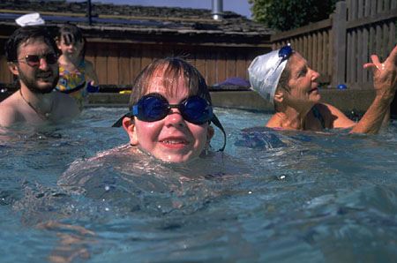Children with asthma take part in all aspects of school life. Physical activity and swimming is particularly beneficial for children with asthma. 

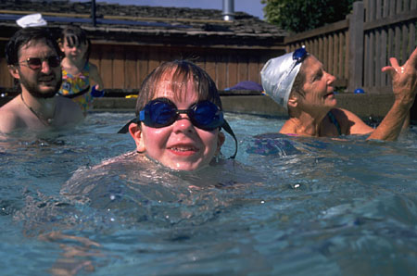

**First aid in school**

First Aid is given to all children in school. However, very often reassurance and a sympathetic voice

is all that is needed.

First Aid systems are as follows: 

* We have a simple first aid box for minor treatment.
* Children will be sent to a First Aider if the cut is very deep, continues to bleed or has a foreign object embedded in it.
* Parents will be informed if the injury is thought to require further medical treatment.
* Bumps to the head will be sent to a First Aider and treated with an ice pack. Depending on how severe the injuries are, parents will be informed. (Bumped head form.)
* In the event of a child fainting or becoming unconscious, the child’s head will be turned to one side or the child put into the recovery position, in case vomiting occurs. Adults will check that no injuries have occurred during the faint.
* In case of a suspected fracture, the child will immediately be referred to a First Aider and the Head teacher informed, who will decide what action to take. In these cases parents will be informed as soon as possible, as further medical advice is required.



