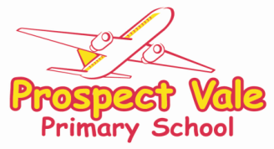

**Meal Pattern Request**

Please complete this form and return to school.

**I want my child to have School Meals:**

Please tick which day/s you would like your child to have a school meal: -

Mon Tue Wed Thur Fri

**I want my child to have Packed Lunches:**

Please tick which day/s you would like your child to have a packed lunch: -

Mon Tue Wed Thur Fri

My child prefers: Meat Halal Vegetarian Any







Allergies or any other preferences if having school meals:   
  
………………………………………………………………………………………………....

Starting from _________________ (Date)

**Payment**

School Meals are £2.30 per day. However, if your child is in Reception, Year 1 or Year 2, your child’s meal is free under the Universal Infant Free School Meal Scheme.

Please note we are not able to accept Childcare Vouchers for dinner money.

I confirm payment will be made via my Parent Pay account and I understand that my account will not fall into arrears.

I think my child could be eligible for Free School Meals because I receive certain benefits.



Please let me know how to apply for Free School Meals.



I understand that if my child wants to change their meal pattern I have to give 1 weeks’ notice by filling out one of these forms again.

Name of child: ________________________________Year: ____________

Name of Parent/Carer: _______________________ Date: ­­­­____________