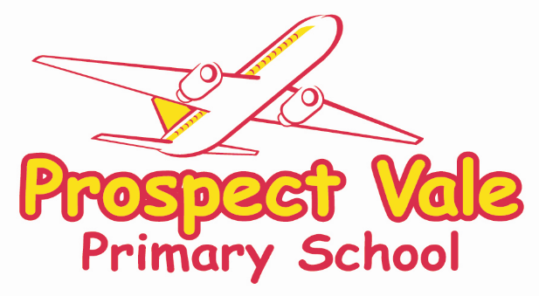

Prospect Vale
Privacy Notice - Pupils

Version | Author | Policy approved by | Approval date | Review date | Changes made?
V1 | Information Governance Team | Information Governance Team | 15.06.2018 | 01.09.2019 | No Changes
V2 | Information Governance Team | Information Governance Team | 01.09.2019 | 01.09.2020 | No Changes
V3 | Information Governance Team | Information Governance Team | 23.09.2020 | 01.09.2021 | Updated changes regarding Lawful basis
V4 | Information Governance Team | Information Governance Team | 10.11.2021 | 01.09.2022 | Changes to Consent

How we use pupil information;

We Prospect Vale are a data controller for the purpose of the UK General Data Protection Regulation (GDPR). We collect information from you and may receive information about you from your previous school, local authority and/or the Department for Education.

We collect your information to;
- to support pupil learning and the delivery of education
- to monitor and report on pupil progress
- to provide appropriate pastoral care
- to assess the quality of our services
- to comply with the law regarding data sharing
- to comply with our statutory obligations

The categories of pupil information that we collect, hold and share include;
- Personal information such as;
- Name, date of birth, gender, image, class details, admission data, unique pupil number, address, family contact details, GP contact details, dietary requirements, school history, attendance, behaviour log
- Special categories of information such as;
- Ethnicity, nationality, religion, country of birth, free school meal eligibility, medical needs, assessment, data, Special Educational Needs and Disability status
We share pupil data with a number of services in order to provide appropriate support for our pupils. This will include Local Authority educational services including specialist inclusion, support and access services as well as health services like School Nursing.

The lawful basis on which we use this information;

Legal obligation;
We are required to use pupil data when undertaking our legal obligations and to comply with our statutory functions.
The following information is processed as a result of the schools’ legal obligation;
  - Pupil Name, Date of Birth, Gender, Image, Class details, Admission Date, ULN, UPN, Address, Family Members, Family Contact Details, GP Contact Details, Dietary Requirements, Ethnicity, Nationality, Religion, FSM, School History, Attendance, Medical Needs, Assessment Data, Behaviour Log, SEN Status.
Consent;
The consent of parents may be relied upon to process some forms of pupil data.
We will request consent in the following circumstances;
- To allow us to process the personal and sensitive information for school visits (Name, DOB, Contact Telephone Number, Medical Requirements)
- When taking photographs of pupils to be used on the school website / used within the school environment
- To share information with the Team Around the School (TAS)
- To share information with the Team Around the Child (TAC)

Where the legal reason for processing your personal information is based on your consent, you have the right to withdraw your consent at any time, without affecting the lawfulness of our processing prior to your withdrawal. Please contact the School Business Manager should you wish to withdraw your consent for any of the above activities.

Collecting pupil information;

Whilst the majority of pupil information you provide to us is mandatory, some of it is provided to us on a voluntary basis. In order to comply with the UK GDPR we will inform you whether you are required to provide certain pupil information to us or if you have a choice in this.

Storing pupil data;

We hold all pupil data in line with the agreed retention schedule.

Who we share pupil information with;

We routinely share pupil information with:

- schools that the pupil’s attend after leaving us
- our local authority,
- the Department for Education (DfE)
- NHS (Eye Tests, Flu vaccines etc)
We will not give information about you to anyone outside this establishment without your consent unless the law permits it. We are required by law to pass some of your information to the Local Authority for monitoring, tracking and provision of appropriate services, and to the Department for Education.
These organisations are then required to share some of this information with trusted partners including NHS Trusts and other Local Authorities in the case of admissions. Appropriate data will be used by certain Local Authority services to provide the best support possibly to children and young people.

Why we share pupil information;
We share pupils’ data with the Department for Education (DfE) on a statutory basis. This data sharing underpins school funding and educational attainment policy and monitoring.
We are required to share information about our pupils with our local authority (LA) and the Department for Education (DfE) under section 3 of The Education (Information About Individual Pupils) (England) Regulations 2013.

Data collection requirements;
To find out more about the data collection requirements placed on us by the Department for Education (for example; via the school census) go to https://www.gov.uk/education/data-collection-and-censuses-for-schools.
The National Pupil Database (NPD)
The NPD is owned and managed by the Department for Education and contains information about pupils in schools in England. It provides invaluable evidence on educational performance to inform independent research, as well as studies commissioned by the Department. It is held in electronic format for statistical purposes. This information is securely collected from a range of sources including schools, local authorities and awarding bodies.
We are required by law, to provide information about our pupils to the DfE as part of statutory data collections such as the school census and early years’ census. Some of this information is then stored in the NPD. The law that allows this is the Education (Information About Individual Pupils) (England) Regulations 2013.
To find out more about the NPD, go to https://www.gov.uk/government/publications/national-pupil-database-user-guide-and-supporting-information.
The department may share information about our pupils from the NPD with third parties who promote the education or well-being of children in England by:
- conducting research or analysis
- producing statistics
- providing information, advice or guidance
The Department has robust processes in place to ensure the confidentiality of our data is maintained and there are stringent controls in place regarding access and use of the data. Decisions on whether DfE releases data to third parties are subject to a strict approval process and based on a detailed assessment of:
- who is requesting the data
- the purpose for which it is required
- the level and sensitivity of data requested: and
- the arrangements in place to store and handle the data
To be granted access to pupil information, organisations must comply with strict terms and conditions covering the confidentiality and handling of the data, security arrangements and retention and use of the data.
For more information about the department’s data sharing process, please visit: https://www.gov.uk/data-protection-how-we-collect-and-share-research-data
For information about which organisations the department has provided pupil information, (and for which project), please visit the following website: https://www.gov.uk/government/publications/national-pupil-database-requests-received

To contact DfE: https://www.gov.uk/contact-dfe

Requesting access to your personal data
Under data protection legislation, parents and pupils have the right to request access to information about them that we hold. To make a request for your personal information, or be given access to your child’s educational record, please contact Prospect Vale to make a request or alternatively you can view our Data Subject Rights Policy on our website.

You also have the right to:
- object to processing of personal data that is likely to cause, or is causing, damage or distress
- prevent processing for the purpose of direct marketing
- object to decisions being taken by automated means
- in certain circumstances, have inaccurate personal data rectified, blocked, erased or destroyed; and
- claim compensation for damages caused by a breach of the Data Protection regulations
If you have a concern about the way we are collecting or using your personal data, we request that you raise your concern with us in the first instance. Alternatively, you can contact the Information Commissioner’s Office at https://ico.org.uk/concerns/

Contact
If you would like to discuss anything in this privacy notice, please contact:
Karen Lane

Data Protection Officer
IGschoolsupport@stockport.gov.uk
0161 474 4299

